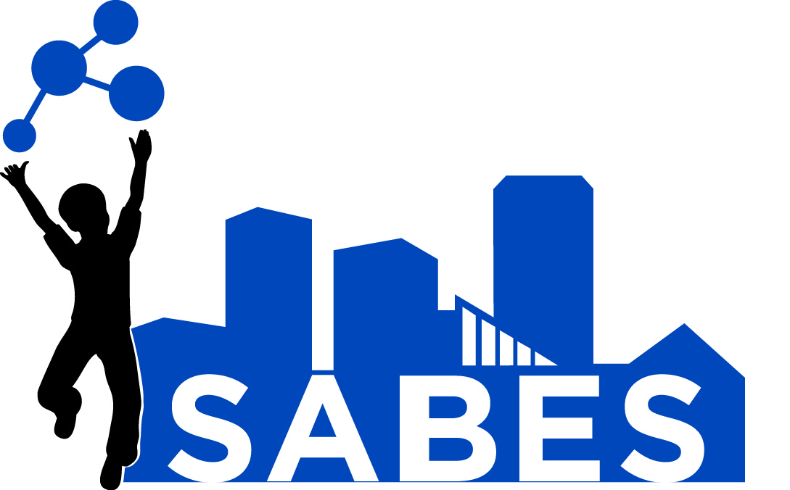
Earth/Space Science STEM Academy Syllabus

Instructors: Lauri Delaney and Megan Healy
Organizer/Content Lead: Amanda Laurier
Location: Gwynns Falls Elementary School #60 – 2700 Gwynns Falls Parkway
Dates: June 25 - 29 and July 2, 2018
Time: 8:30 am-3:30pm. Lunch will be working lunches. Otherwise, lunch assignments will be made up as homework. Lunch is not provided.

Email: ldelaney01@bcps.k12.md.us , mkhealy@bcps.k12.md.us, alaurier@bcps.k12.md.us

Course Description: This course is designed as an introduction to basic concepts in Earth/Space Science addressed in the Next Generation Science Standards. Participants will engage in hands-on inquiry to learn about and experience concepts related to Earth Science and Astronomy. Content-related topics include: characteristics of stars and galaxies; components of our Solar System; interactions within the Earth-Moon-Sun system; processes and events causing changes to Earth’s surface; interactions between the hydrosphere and other spheres on Earth; plate tectonics; Chesapeake Bay; Earth’s natural resources, and human impacts on the environment.

Main Objectives:
- Learn basic concepts of various Earth/Space science topics and hands-on learning methods
- Practice hands-on, inquiry-based learning and learn implementation approaches for particular classroom settings
- Develop an understanding of science content, pedagogy, and science and engineering practices necessary for the successful implementation of the STEM curriculum
- Learn best teaching practices relevant to the teaching of STEM
- Develop an understanding of assessment methods and tools used to measure student progress
- Understand the value and importance of working collaboratively with other teachers

Required Materials:
Access to the BCPSS SharePoint course site.
Laptop, or another personal computer/device.
Composition books to create Science Journal

Attendance Policy: Participants are expected to arrive on time and to participate in all classes as scheduled. For each 3 hours of class time missed, participants will be required to complete a make-up assignment. Participants cannot miss more than 6 hours of class. Homework: For the summer session, homework will be completed during working lunches and at the end of the afternoon activities as a group. Every topic will be summarized with videos or articles that will be linked on SharePoint. Sessions will focus on reinforcing and building on the concepts covered in the podcasts and videos through hands-on activities and discussions. The homework assignment will also be posted on the SharePoint class site. These assignments will be collected as part of your class credit.
Grading: All homework assignments will be scored according to the points shown in the table below. A minimum score of 7/10 is required in each of the assignments to earn credit for the course. If a participant earns less than 7/10 on any homework assignment, he/she has until the next session to improve and re-submit it for grading.

 | 4 | 3 | 2 | 1 | 0
Effort and Completion |  | Good effort is evident on assignment and assignment was fully completed | Effort is evident on assignment but it was only partially completed | Minimal effort was given on assignment and/or assignment was not fully completed | Insufficient evidence of effort and/or assignment was not completed
Usage of Scientific Vocabulary |  | Scientific vocabulary was used throughout response and was used correctly | Some scientific vocabulary was used in response and most was used correctly | Minimal scientific vocabulary used in response and/or vocabulary was used incorrectly | No scientific vocabulary used in response or vocabulary was used incorrectly
Evidence of Scientific Reasoning and Logic Applied to Reponses | Exceptional evidence of scientific reasoning and/or logic in response | Adequate evidence of scientific reasoning and/or logic in response | Some evidence of scientific reasoning and/or logic in response | Minimal evidence of scientific reasoning and/or logic in response | No evidence of scientific reasoning and/or logic in response

During each class, participants will be issued a “participation grade” based on their engagement in the work. This means that participants should be on-task at all times, and all side conversations and any use of technology (i.e. cell phones/tablets) should be connected to the course material.

Participants are responsible for watching all podcast videos prior to each session. The content in these videos will be referenced during the face-to-face sessions and will help to ensure rich conversations.

A pre/post assessment is used for research purposes only. The assessment contains information covered both in class and in the podcast videos. There will be no graded quizzes, exams or projects.

Three AUs and three CPD MSDE credits will be awarded for the successful completion of the course. Successful completion will be evaluated based on session attendance, homework grades, evidence of the podcasts’ viewing prior to each class, and participation grades.

Statement of Academic Continuity: Please note that in the event of weather and/or in other extraordinary circumstances, the Facilitators may change the normal academic schedule and/or make appropriate changes to course structure, format, and delivery. In the event such changes become necessary, information will be posted on the SharePoint site.

Schedule of Topics (subject to change):

Session # | Date | Objectives | Phenomena to Explain | Science Concepts | NGSS | Correlation to SABES Units
Day 1 AM  Earth’s Interior Structure & Plate Tectonics I | Monday, June 25, 2018  (8:30-11:30) | - Construct and understand a model of the Earth’s layers.  - Explore plate tectonics and how it shapes the Earth’s surface.  - Explore Earth’s magnetism and how it proves the theory of plate tectonics.  - Analyze common misconceptions about the Earth’s interior structure and plate tectonics.  - Understand and compare different systems that shape Earth’s surface.  - Explore volcanoes.  - Analyze common misconceptions about the Earth’s interior structure and how it shapes the Earth’s surface. | - What are the layers of Earth made of?  - Is the Earth like a giant N-S bar magnet?  - Did dinosaurs and cave men live at the same time?  - Can we observe plate movement in our lifetime?  - Is there a relationship between plate movement and sea level?  - How are mountains created?  - Where do volcanoes occur? | - Crust, Mantle, Core  - Plate tectonics  - Lithosphere  - Liquid & solid convection  - Magnetism  - Ring of Fire & Volcanoes | 2-ESS1-1  2-ESS2-2  4-ESS2-2  MS-ESS1-4  MS-ESS2-2  MS-ESS2-3 | Grade 3 Extreme Earth  Grade 4 Where in the World?
Day 1 PM  Geology-  Changes to the Earth’s Surface | Monday, June 25, 2018  (12:30-3:30) | - Differentiate rocks and minerals, and explain how they’re formed.  - Differentiate fossil types and explain how they’re formed.  - Explain the processes of weathering and erosion, and understand how the processes work together to change the surface of the Earth. | - Are fossils made from plants and animals that were turned to stone over time?  - Where does sand come from?  - Can weathering, erosion, and deposition drastically alter a land form in one season?  - How does the Earth’s surface change? | - Classification of rocks and minerals  - Weathering, erosion, and deposition  - The constantly changing landscape | 2-ESS1-1  2-ESS2-2  4-ESS1-1  4-ESS2-1  4-ESS2-2  MS-ESS1-4  MS-ESS2-2  MS-ESS2-1 | Grade 3 Extreme Earth  Grade 4 Where in the World?
Day 2 AM  The Hydrosphere | Tuesday, June 26, 2018  (8:30-11:30) | - Identify the different Earth system spheres: Hydrosphere, Biosphere, Geosphere (Lithosphere), Atmosphere, Hydrosphere, Cryosphere.  - Explore examples of interactions between the Earth’s hydrosphere & other spheres.  - Understand where the water and the salt come from in the Hydrosphere. | - Where did the water and salt on Earth come from?  - How does the water cycle work?  - How does the hydrosphere interact with other spheres on Earth? | - Water cycle  - Interaction among spheres on Earth  - Water and salt origination | 4-ESS1-1  4-ESS2-1  5-ESS2-1  5-ESS2-2  5-ESS3-1  MS-ESS2-4 | Grade 3:  Water Cycle
Day 2 PM  Weather | Tuesday, June 26, 2018  (12:30-3:30) | - Understand natural weather phenomena and disasters such as the greenhouse effect, tornados, and thunderstorms.  - Explain high and low pressure systems in weather.  - Understand the Coriolis Effect by constructing a model.  - explore global scale wind patterns  - Discern between El Nino and La Nina phenomena. | - How does natural weather phenomena occur, like tornadoes, thunderstorms, and blizzards?  - Why do we have wind?  - What’s the difference between high and low pressure?  - What is the Coriolis Effect?  - Why do we experience certain water patterns on Earth, like El Nino and La Nina? | - Weather  - Temperature  - Weather systems and patterns  - Weather phenomena (El Nino, La Nina)  - Wind Patterns | K-ESS3-2  MS-ESS2-5  MS-ESS2-6 | Grade 5:  Weather Watchers
Day 3 AM  Climate & Climate Change | Wednesday, June 27, 2018  (8:30-11:30) | - Discern between weather and climate.  - Learn about how ice cores provide clues about climate and climate change in the past.  - Determine through graphing that Earth’s climate has sustained a regular cycle of climate change over time.  - Understand a correlation between the rise in temperature and the rise in carbon dioxide in our atmosphere.  - Participate in an informative discussion about global climate change. | - What’s the difference between weather and climate?  - How does weather and other things impact climate?  - How does climate change affect Earth, people, animals, etc?  - What role do greenhouse gases play in climate change?  - What clues does Earth provide that climate change is occurring?  - How does the Coriolis Effect change Earth’s climate?  - How do wind patterns affect climate? | - Climate  - Climate change  - Wind  - Greenhouse gases  - Wind Patterns | K-ESS2-1  K-ESS3-2  3-ESS2-1  3-ESS3-1  MS-ESS2-5  MS-ESS2-6  MS-ESS3-5 | Grade 5 Weather Watchers
Day 3 PM  Natural Resources & Human Impacts on the Environment | Wednesday, June 27, 2018  (12:30-3:30) | - Explore case studies that involved natural resources & human impacts to the environment.  - Explore fossil fuels, nuclear power, coral bleaching, invasive species, and natural calamities.  - Understand the values of renewable and non-renewable resources. | - How do humans negatively and positively impact the environment?  - What are fossil fuels?  - What is the difference between renewable and non-renewable resources?  - What evidence is there that the environment is changing?  - What other forms of energy could we use to help the environment? | - Fossil fuels  - Nuclear power  - Coral bleaching  - Invasive species  - Renewable resources  - Non-renewable resources | K-ESS3-3  4-ESS3-1  MS-ESS3-3  MS-ESS3-4 | Grade 5: Conserving Resources  Grade 5: Electric Wind
Day 4 AM  Stars, Galaxies, and the Universe | Thursday, June 28, 2018  (8:30-11:30) | - Identify the components of the universe and galaxies  - Understand black holes  - Explore the makeup of stars  - Understand the history of the universe and its creation | - How do we know what to know about the Universe if we/never traveled beyond our moon?  - Is “Interstellar” Science real?  - Do Black Holes exist?  - What is a Light Year?  - Are we really made of star dust?  - What’s a Milky Way?  - How far away are stars? | - Black holes & quasars  - Big Bang  - Expanding Universe  - Supernovae and Black Holes  - Evolution of stars | 5-ESS1-1 | Grade 5 There is more to Light that meets the Eye
Day 4 PM  Our Solar System | Thursday,  June 28, 2018  (8:30-11:30) | - Identify the objects in our Solar System  - Explore the scaling of our Solar System  - Understand gravity and weightlessness on Earth and in space | - How many stars are in the Solar System?  - Why do astronauts float in space?  - Are there places in the Universe without gravity?  - What is the brightest star in the sky?  - Why is Pluto no longer a planet?  - Is there life on other planets?  - How far is far? | - Gravity and Orbits  - Gravity and Weightlessness  - Scaling of solar system  - Objects in the Solar System: planets, asteroids, comets, and meteorites  - Planet vs Star  - Formation of the Solar System | 5-ESS1-1  MS-ESS1-2  MS-ESS1-3 | Grade 5 Patterns in the Sky  Grade 3 Sheep in a Jeep (Falling Races)
Day 5  The Chesapeake Bay Watershed  SERC Trip  Full day | Friday,  June 29,  2018  (9:00–3:00) | - Participants will identify the habitats and animals that make up the Chesapeake Bay Watershed.  - Participants will determine how humans impact the Chesapeake Bay.  - Participants will determine how humans can help control and stop pollution in the Bay. | - How do humans impact the Bay?  - What habitats are found around and in the Bay?  - What animals live in the Bay?  - What are the biggest pollutants in the Bay?  - How can humans help to stop pollution in the Bay? | - Brackish water  - Ecosystems  - Habitats  - Watersheds  - Pollution  - Human Impact | 5-ESS2-1  5-ESS3-1  5-PS3-1  5-LS2-1 | Grade 3: Save the Bay!
Day 6 AM  Sun-Earth System | Monday,  July 2, 2018  (8:30-11:30) | - Determine the reason for seasons, day/night, shadows, and length of days on Earth  - Understand constellations and how they are seen from all over the Earth throughout the year  - Explain the relationship between Sun and Earth | - What is the reason for the seasons?  - What happens to stars and constellations over a day? over a year?  - Do all stars rise and set?  - Why are days shorter in the winter?  - When can you have no shadow?  - What’s a year?  - What’s a day? | - Shadows  - Sunrise and sunset  - Seasons  - Day and Night  - Length of a day  - Changing constellations  - Sun’s altitude and path in the sky  - Distance between Sun and Earth | 1-ESS1-1  1-ESS1-2  5-ESS1-2 | Grade 5 Patterns in the Sky
Day 6 PM  Sun- Earth-Moon System  Final Assessment | Friday,  June 30, 2017  (12:30-3:30) | - Create and use models to understand rotation, phases, and orbit of the moon  - Understand the relationship between the Sun, Earth, and Moon  - Explain how the Moon affects motion of water on Earth | - Would Earth still have tides if there was no moon?  - Why does the moon change its phases?  - What’s a month?  - Why do we only see one side of the moon?  - How does the moon affect the motion of water on Earth? | - Tides  - Phases of the moon  - Eclipses  - Moon’s rotation and revolution  - Day on the Moon  - Moon tide relationship | 1-ESS1-1  MS-ESS1-1

